Mark Christian Garing

BSIT - 4

G5

CSIT360 – Introduction to Blockchain Laboratory Midterm Examination

DATE : 10/22/2025  
  
1.  
  
 a.

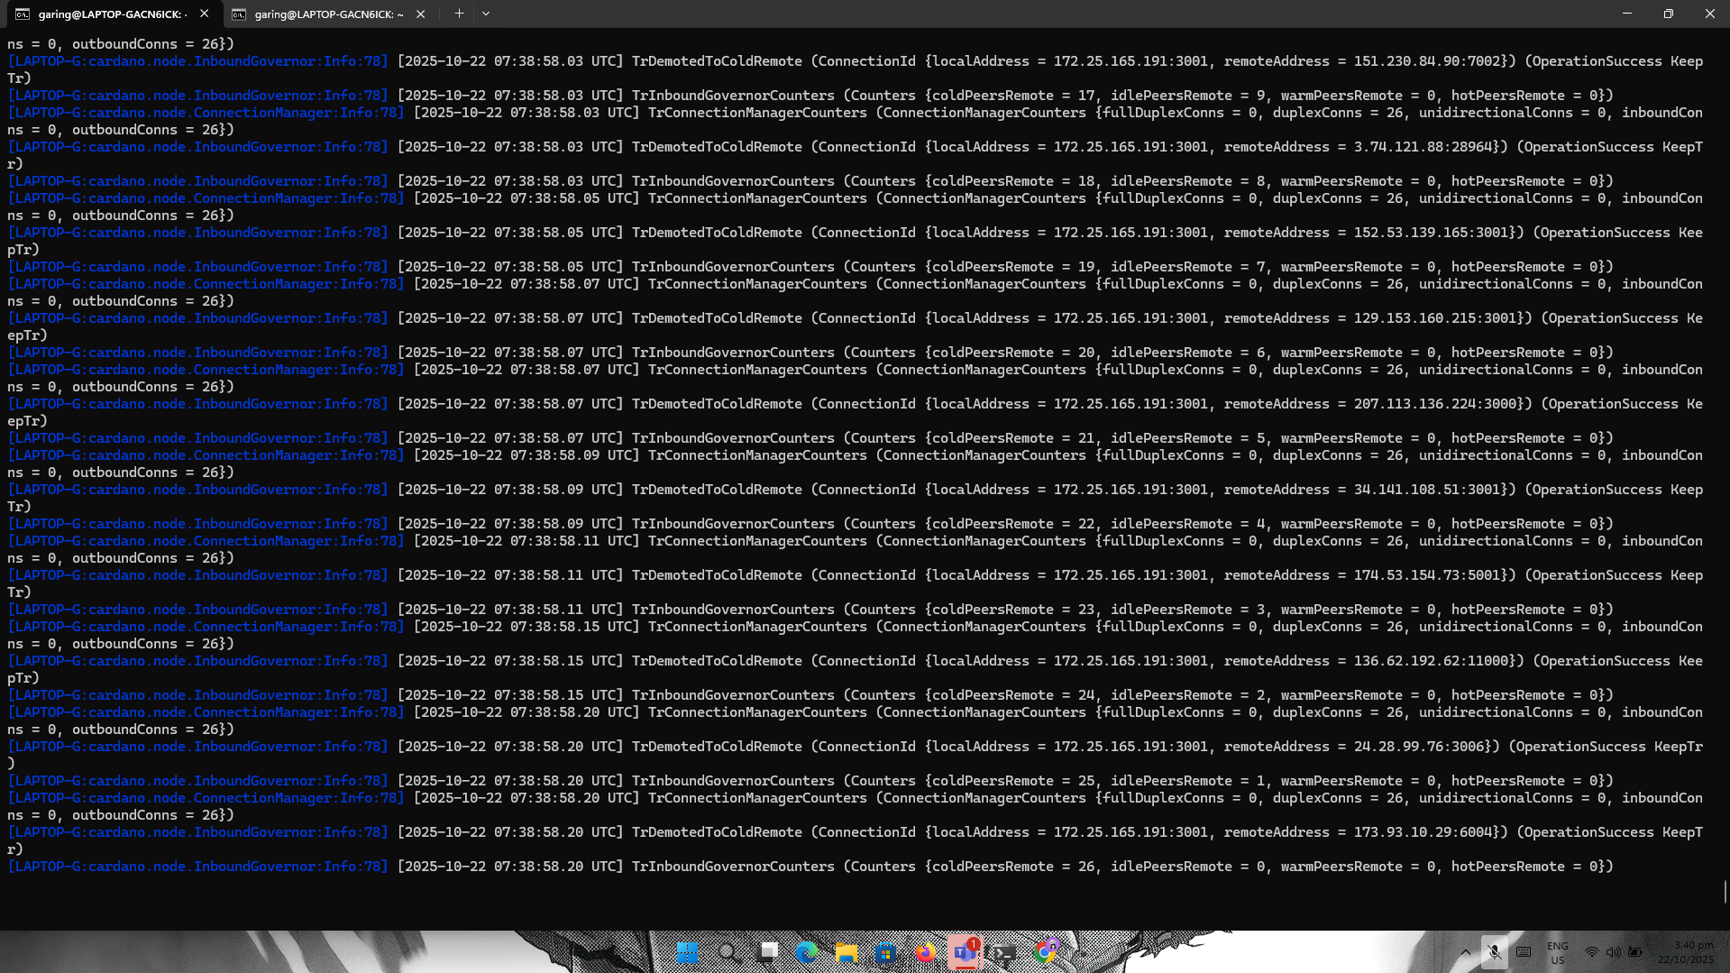

b. 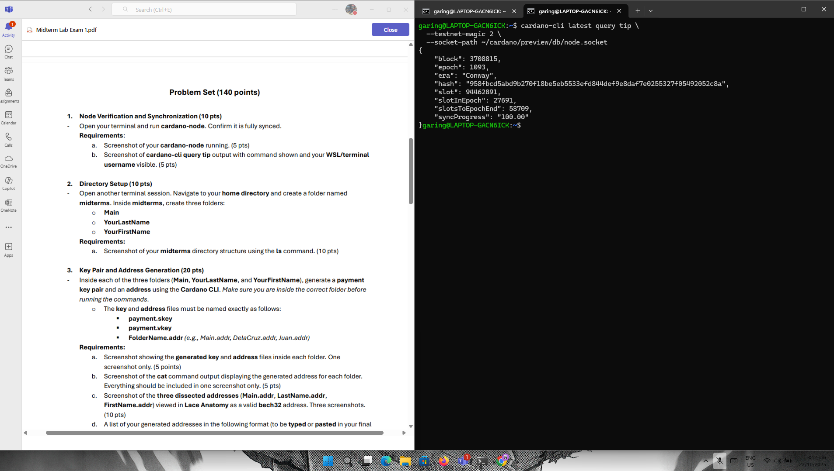

2.

a. 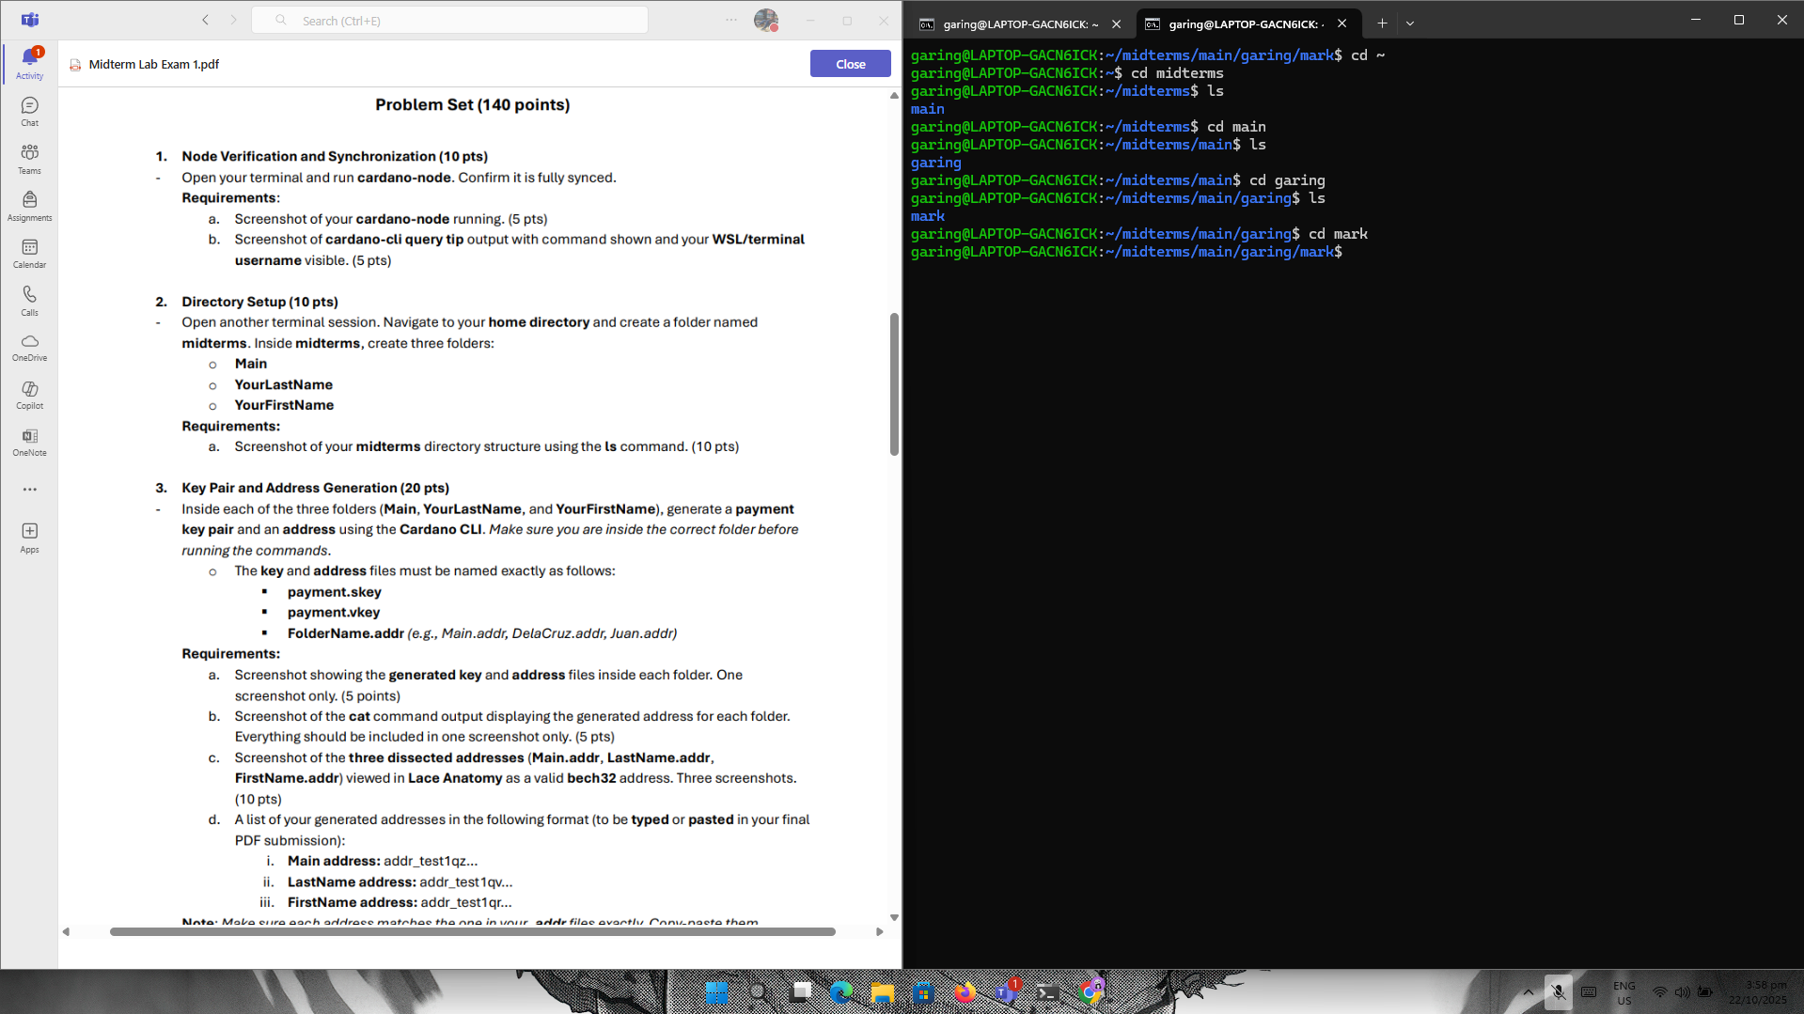

3.

a.

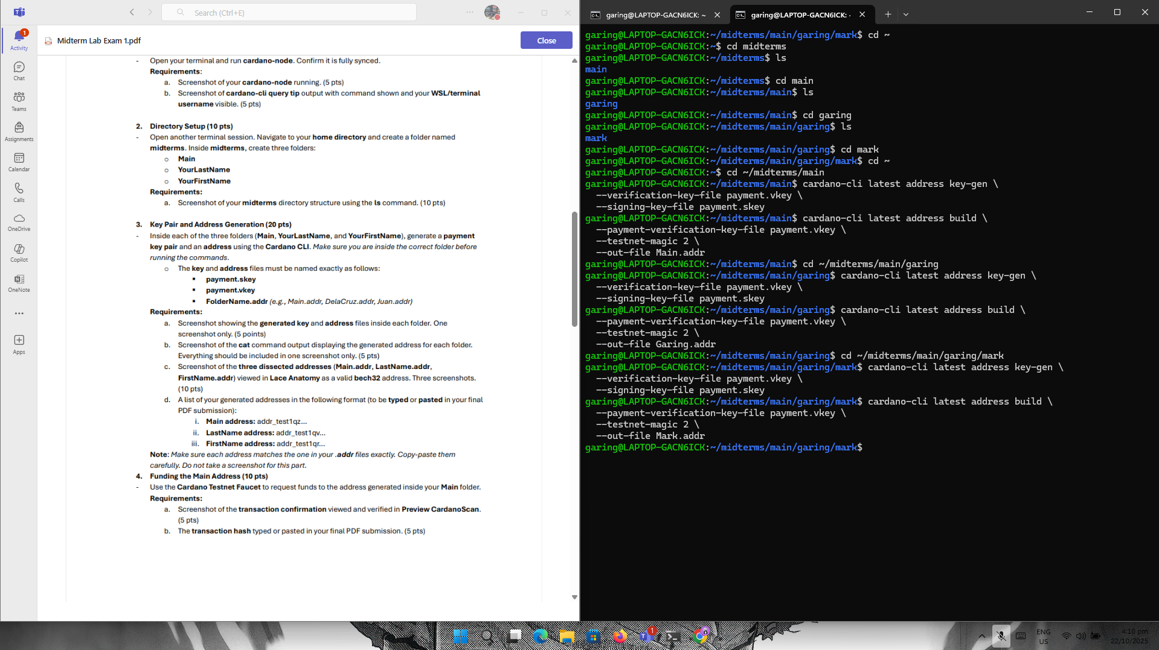

b. 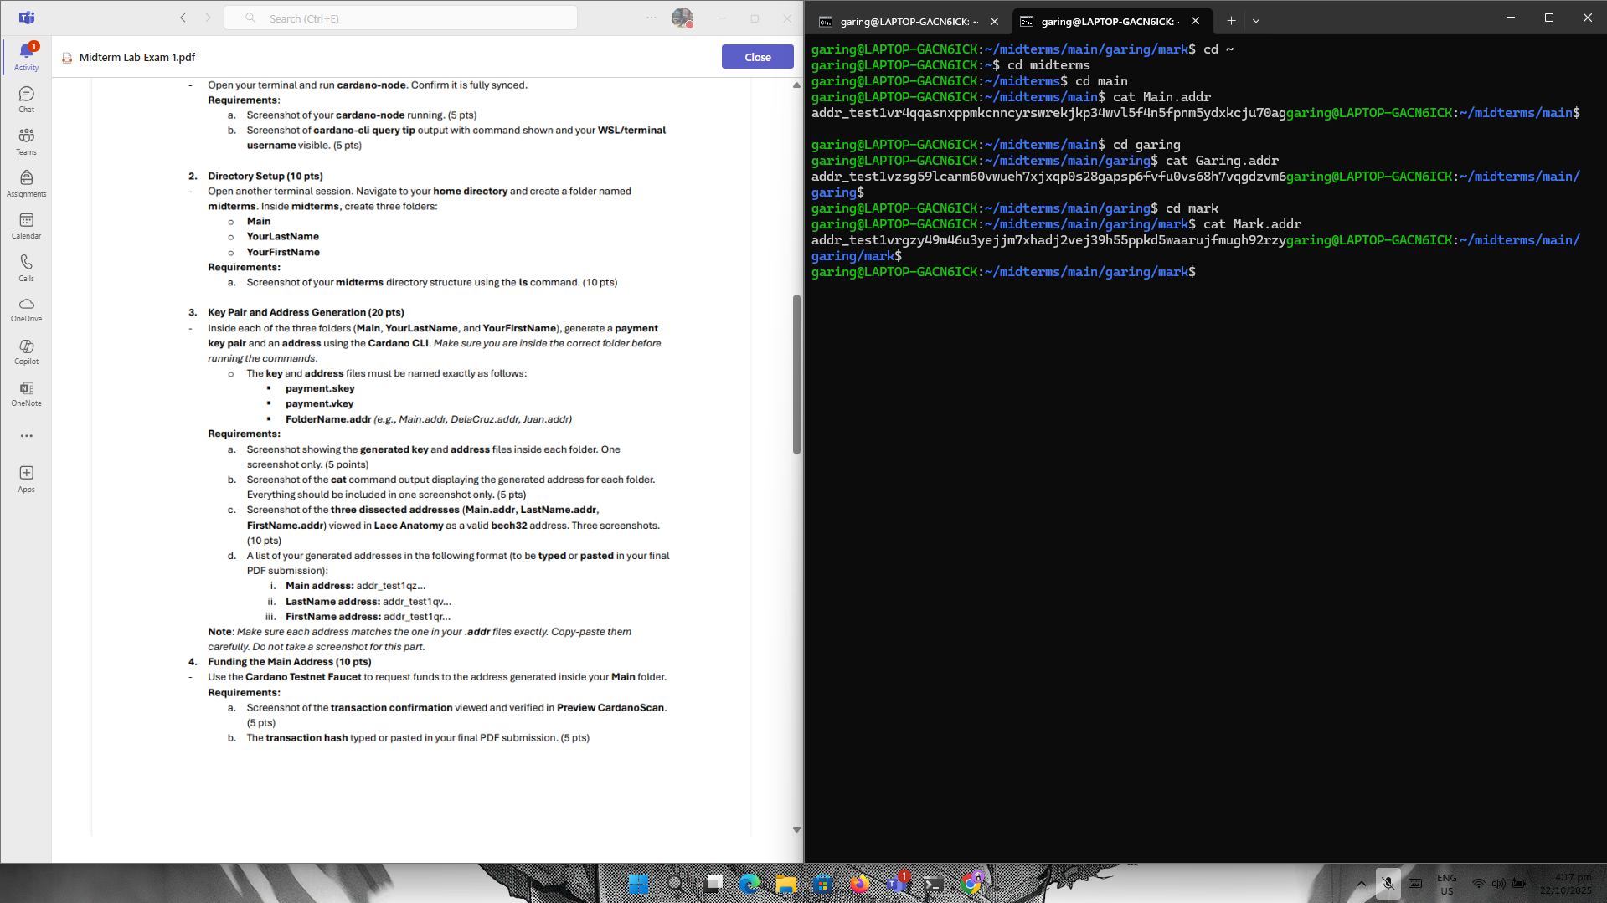

c.

Main.addr: 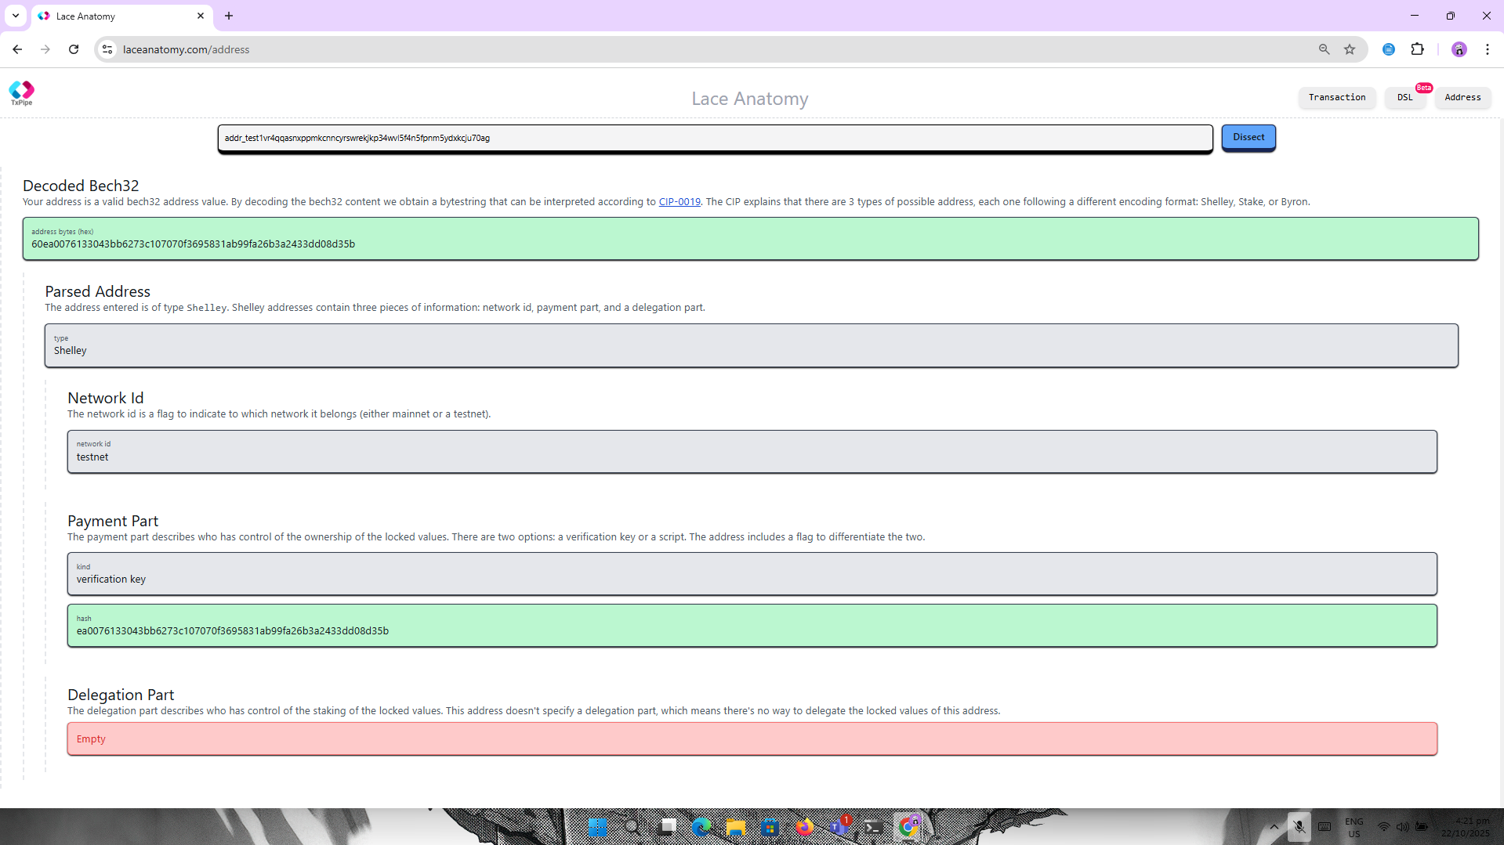

Garing.addr:  
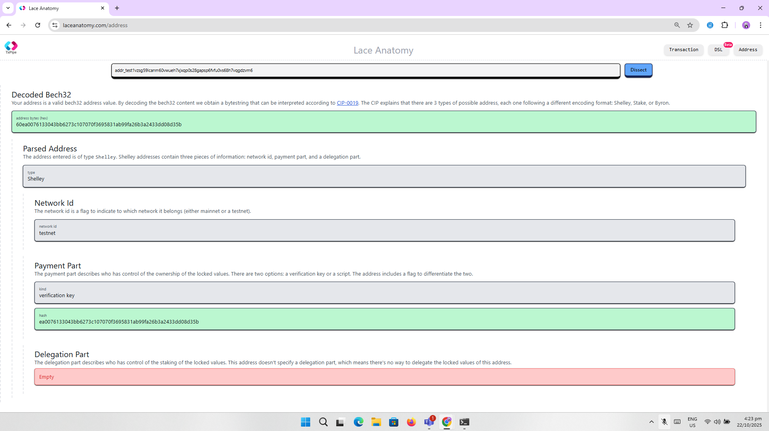

Mark.addr: 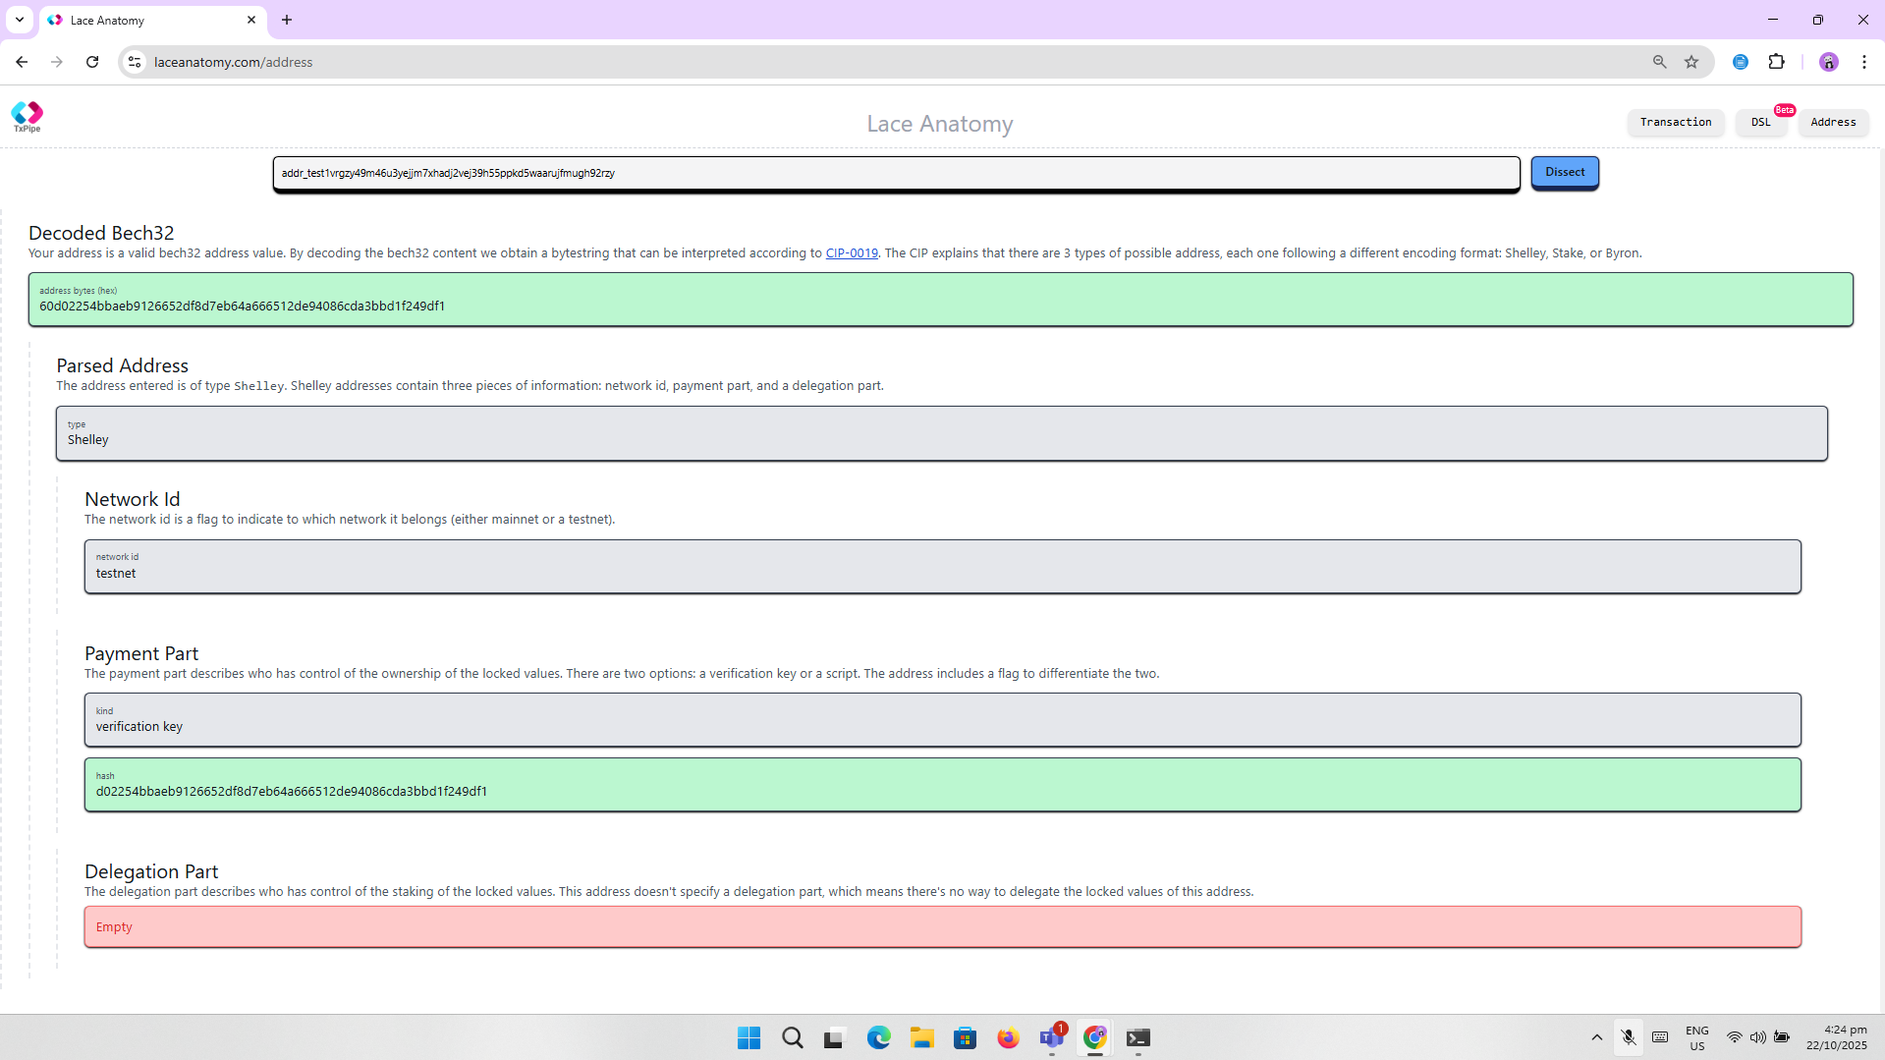

D.  
  
Main.addr: **addr_test1vr4qqasnxppmkcnncyrswrekjkp34wvl5f4n5fpnm5ydxkcju70ag**

Garing.addr: **addr_test1vzsg59lcanm60vwueh7xjxqp0s28gapsp6fvfu0vs68h7vqgdzvm6**

Mark.addr: **addr_test1vrgzy49m46u3yejjm7xhadj2vej39h55ppkd5waarujfmugh92rzyg**

4.

1. 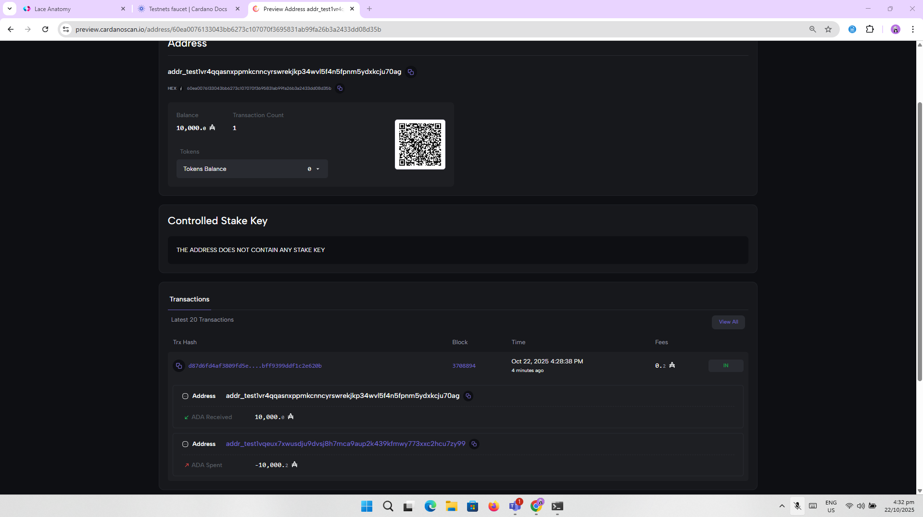

1. Transaction Hash : **d87d6fd4af3809fd5eae7131eb5d884881e7809e763da6bff9399ddf1c2e620b**

5.

1. 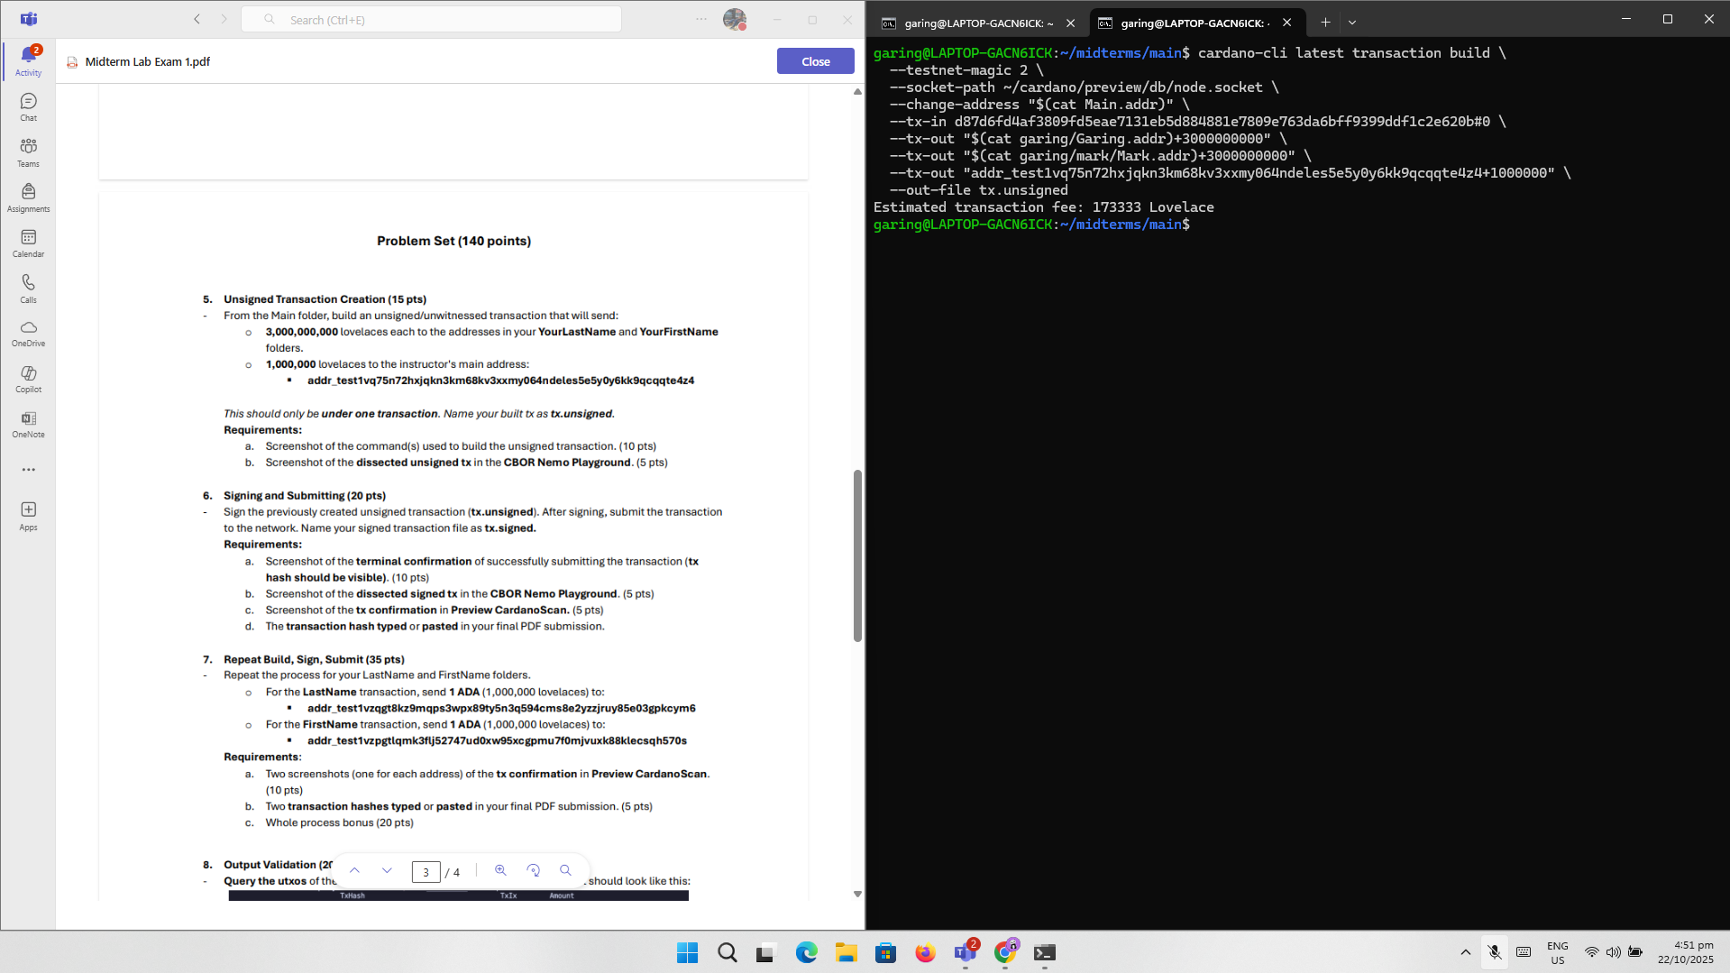
2. 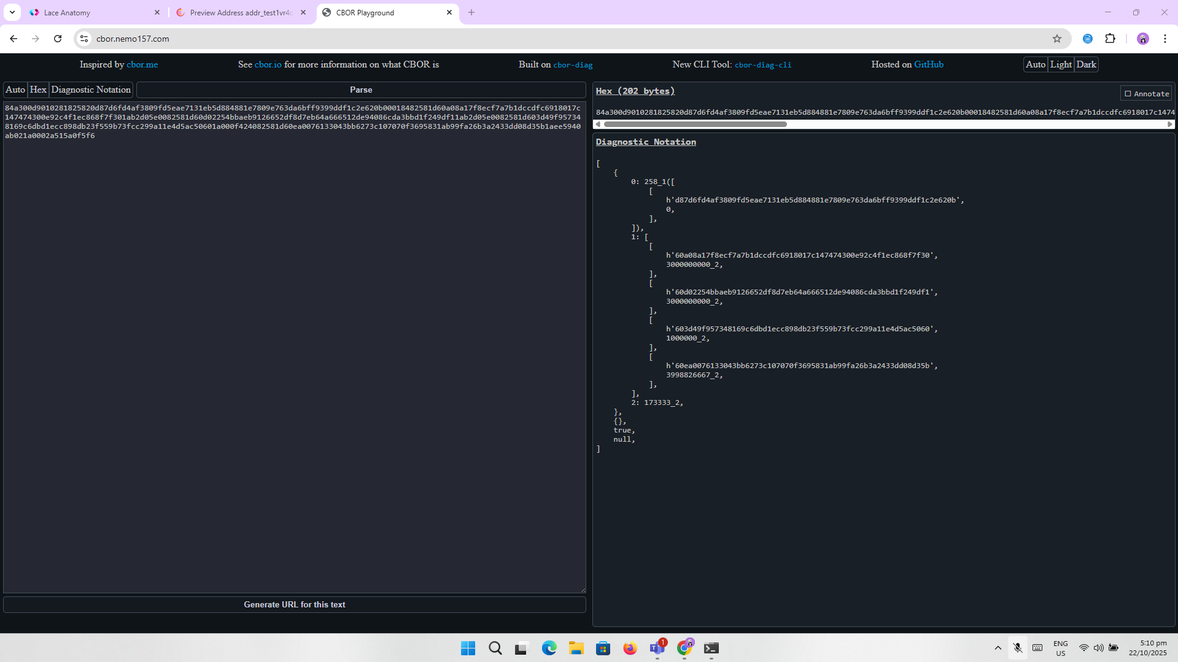

6.

1. 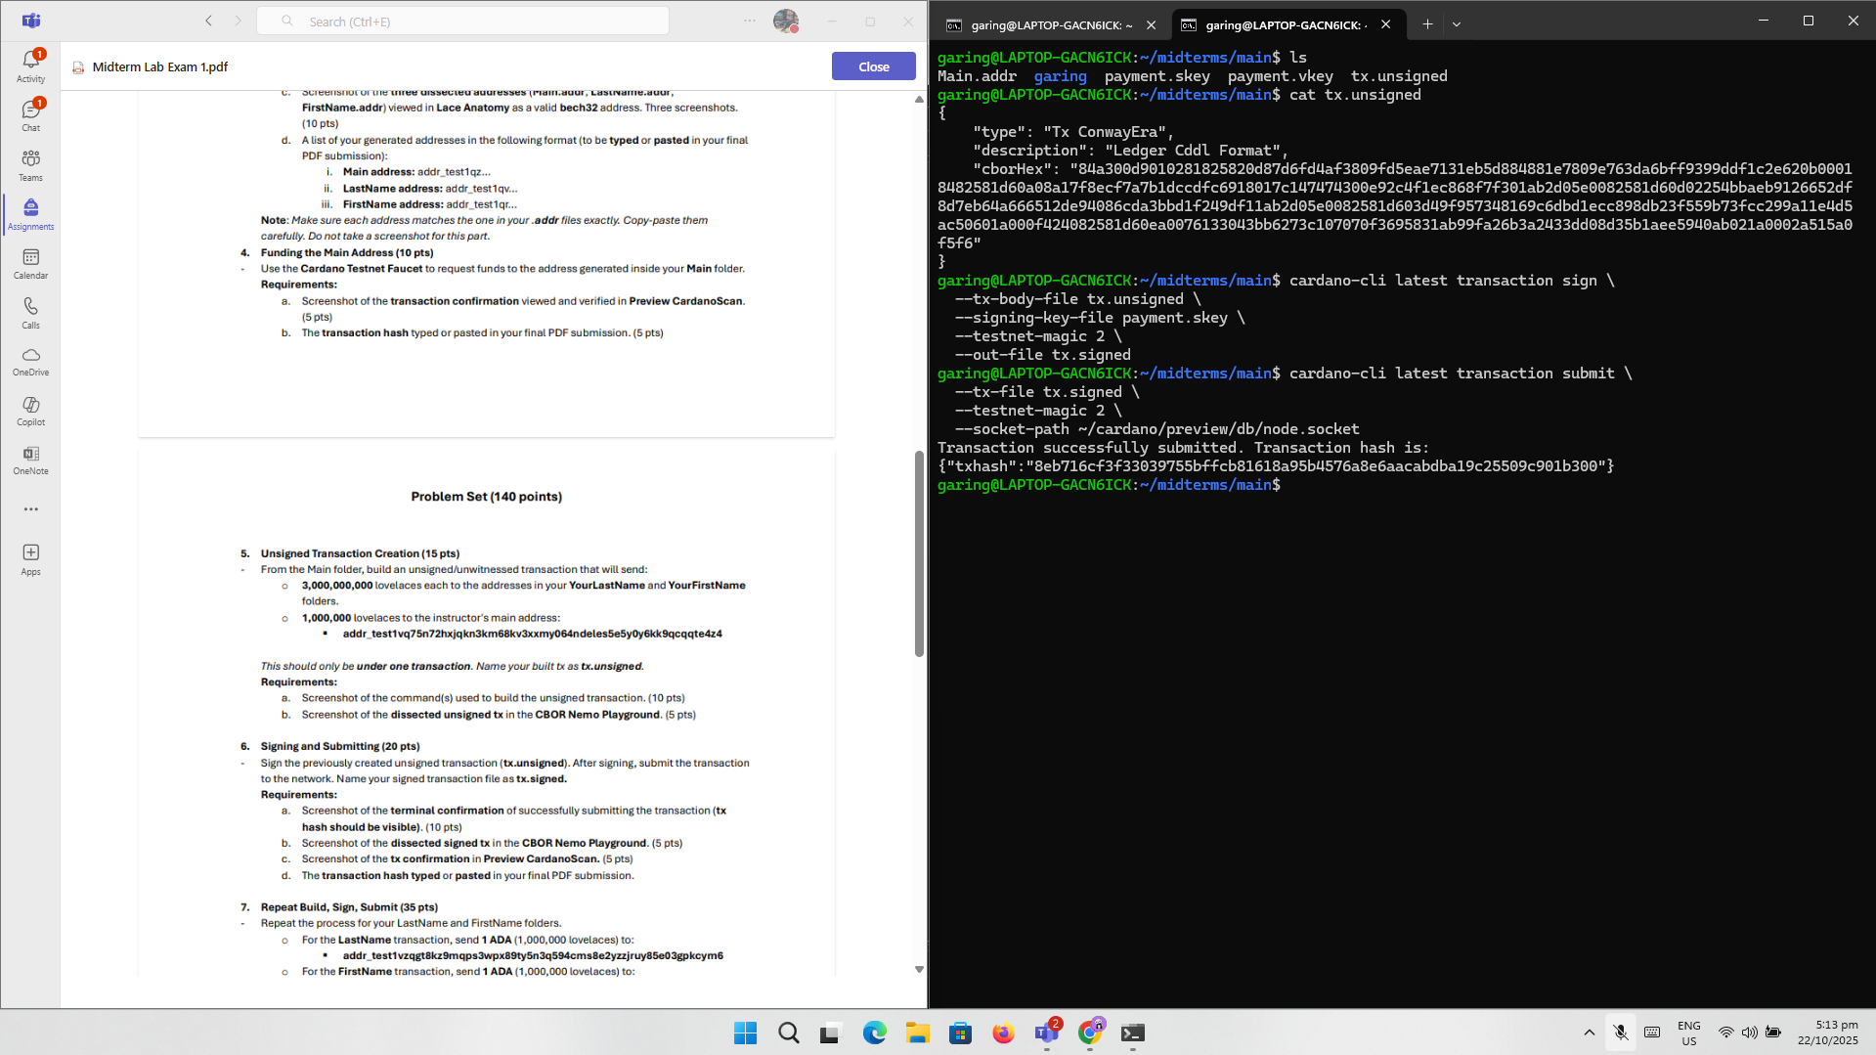
2. 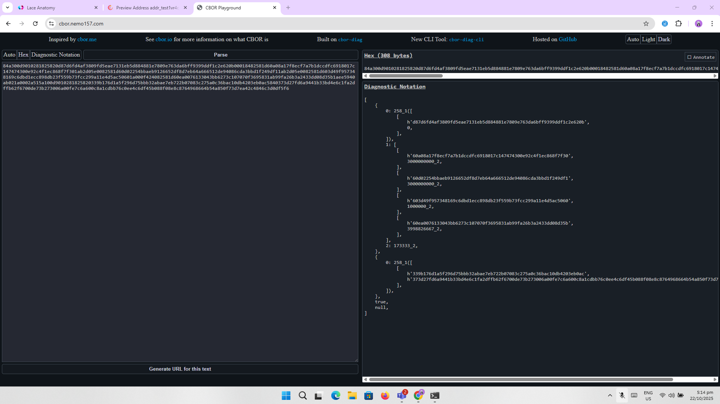
3. 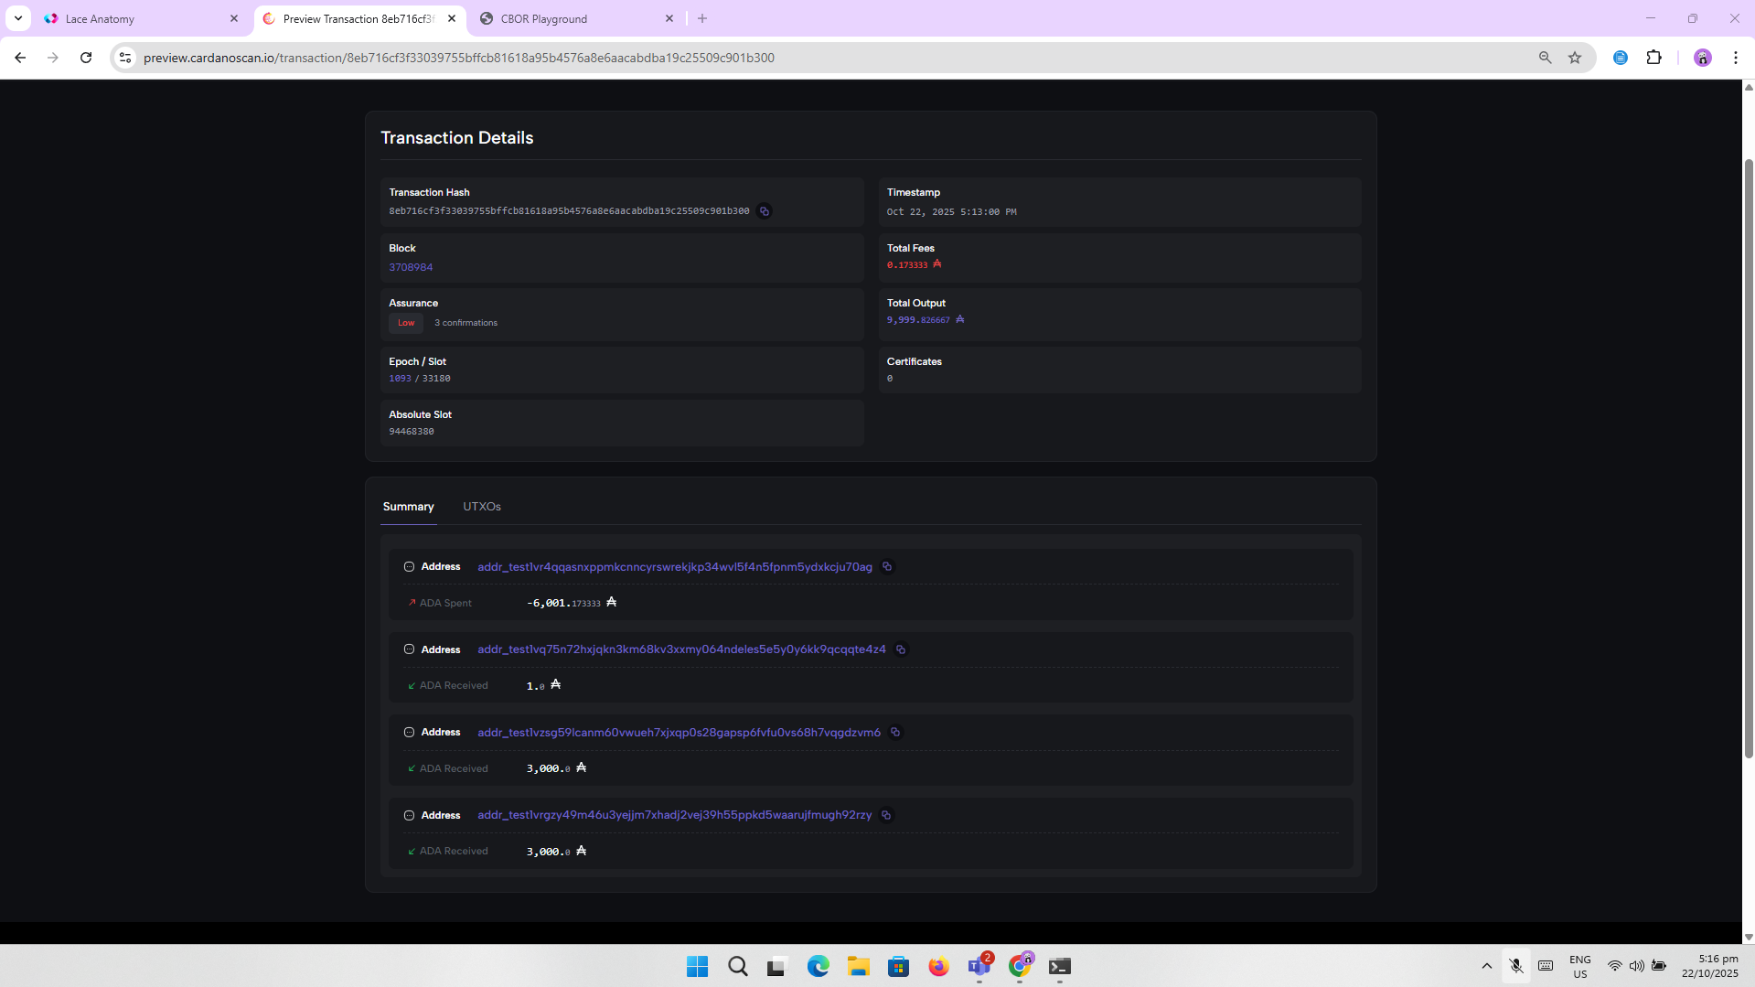
4. Transaction Hash: **8eb716cf3f33039755bffcb81618a95b4576a8e6aacabdba19c25509c901b300**

7.

1. 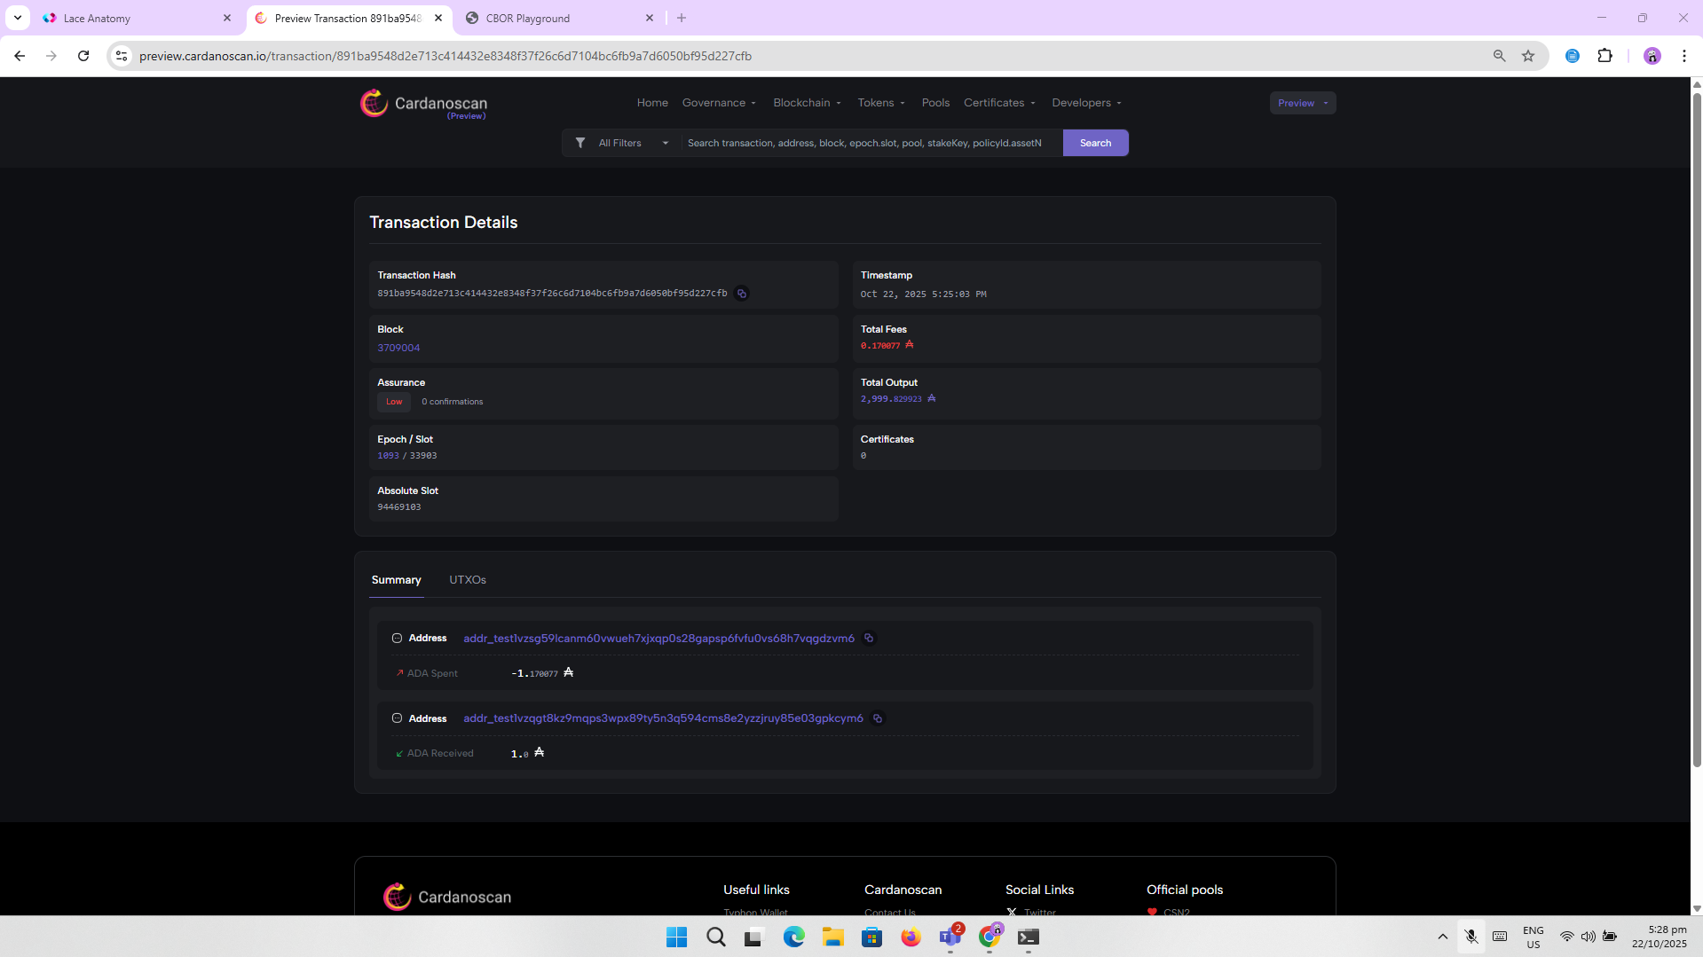

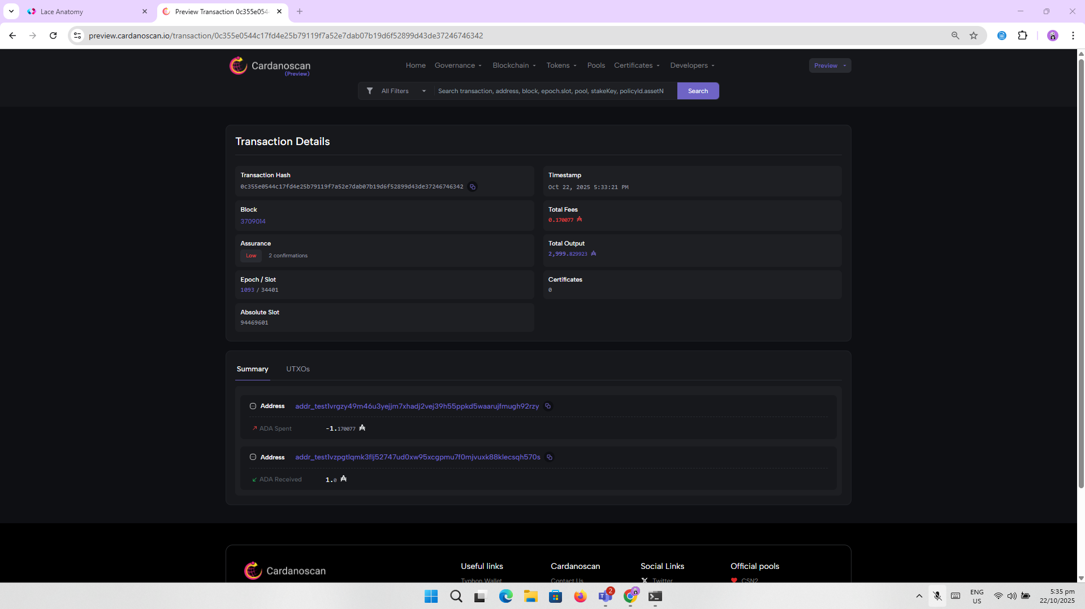

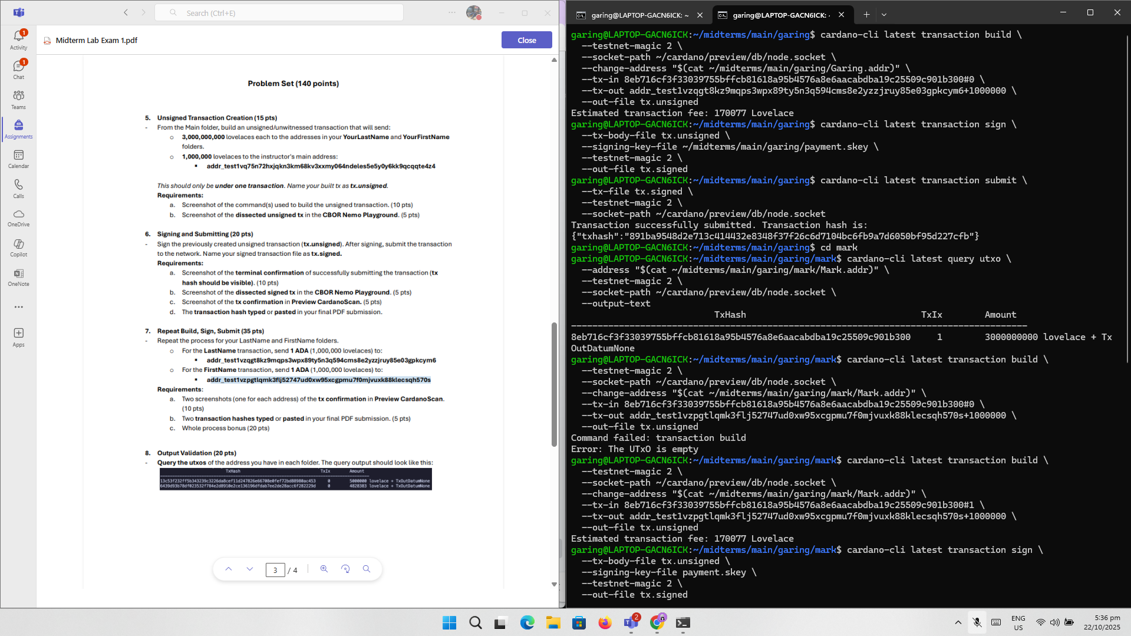

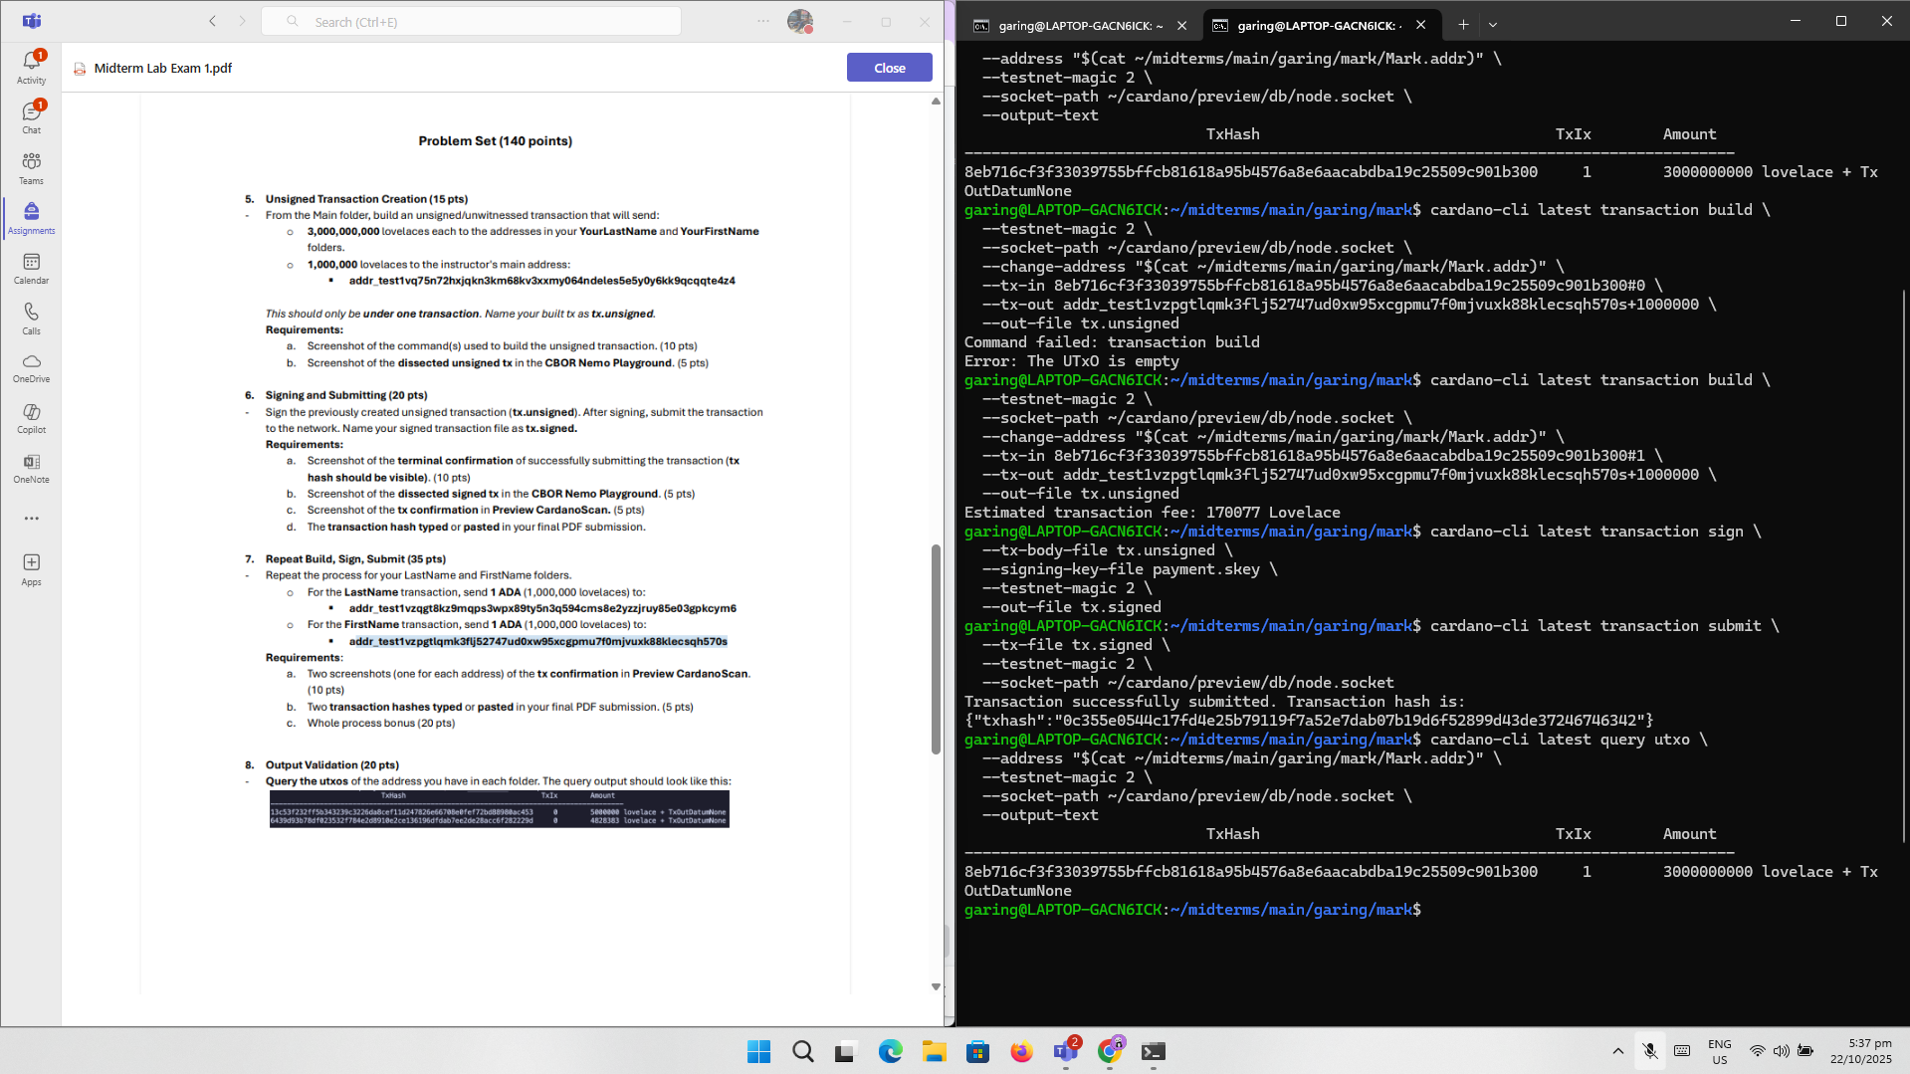

1. Garing Transaction **Hash:891ba9548d2e713c414432e8348f37f26c6d7104bc6fb9a7d6050bf95d227cfb**

Mark Transaction Hash: **0c355e0544c17fd4e25b79119f7a52e7dab07b19d6f52899d43de37246746342**

8.

a.

Main: 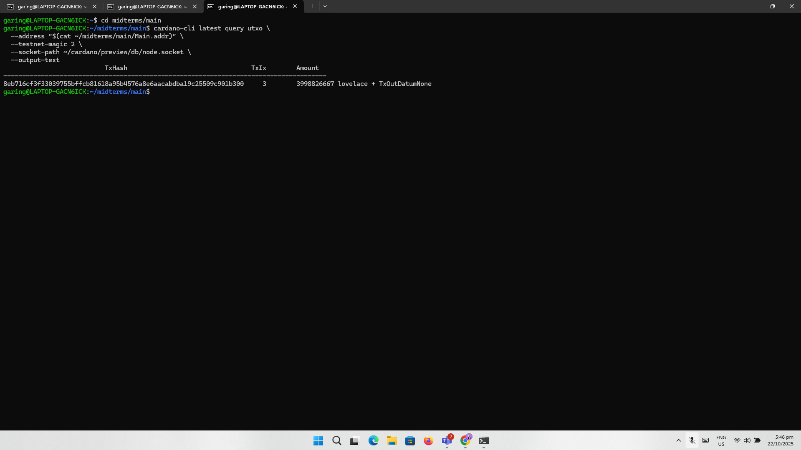

Garing: 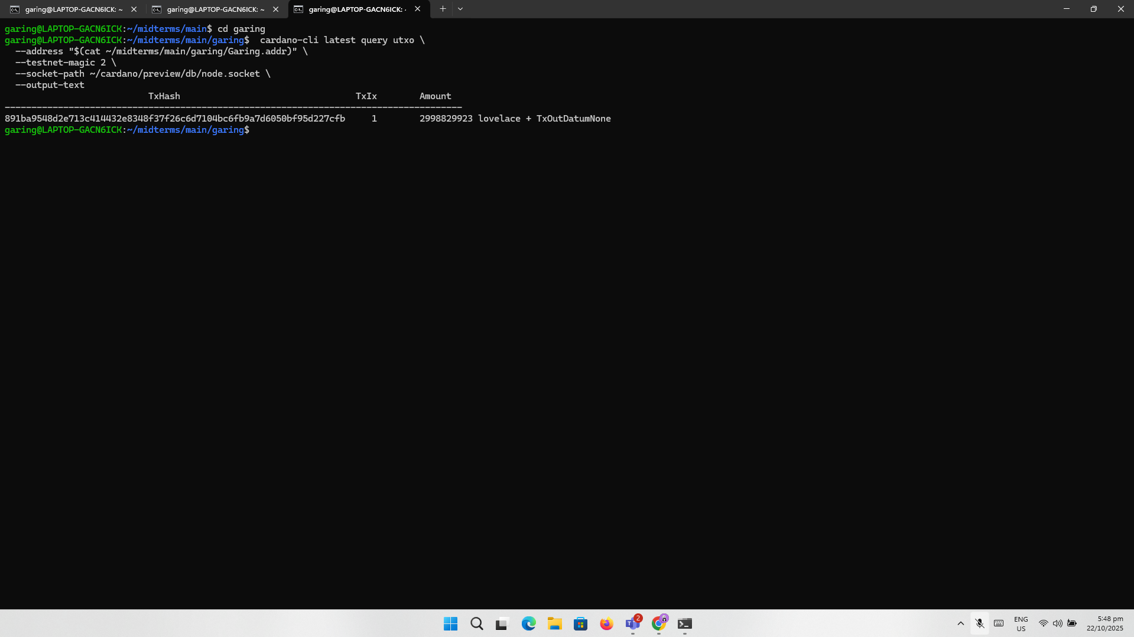

Mark :

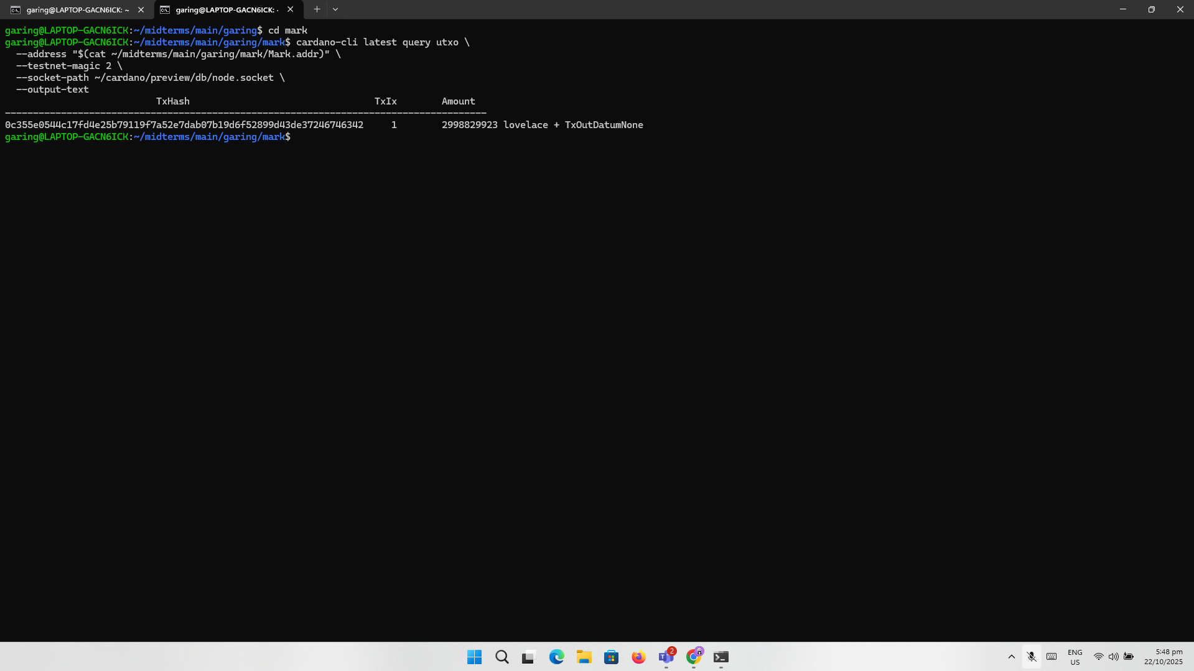  
  
 Thanks Sir, Have a Blessed Day!!!.